Tools
Template Name: CB Utilities v3.dotm
List of Keystroke or Utility Macros
Keystroke | What it does | Macro Name | Module
- Alt C, R | Code updated to be much cleaner and to accommodate both the new 2016 Riders and still support the old Riders. Note: Still needs to be tested on K12.  - Deletes all the highlighted paragraphs with the names of riders and the fields, invisible to the naked eye, at the end of these paragraphs  - Also formats the rider's title so it automatically falls on the next page.  - Deletes the highlighted paragraph with the name of the active rider. Same as the 1st bullet  - And UNLINKS the field of the active rider. THIS is IMPORTANT because any changes made in the rider will be lost upon a field update, which can also happen when a document is printed out---if "Update Fields" on print is set. Of course pressing "F9" will totally wipe out any changes you've made if the rider is STILL a field.  - Modified June 7, 2016 to automatically switch on Redlining. | Clean_Up_Riders | modCBContractTools_v2  clsCBRiders
- Alt-F,D | Converts any selected date and time if that is included too to “mmmm dd, yyyy format  For example: 6/29/1964 converted to June 29, 1964  You have to select the entire date.  Revision July 20, 2016: format changed from “mmmm dd, yyyy” to "mmmm d, yyyy" to fix 09/1/2016, for example being converted to “September 1, 2016” instead of “September 01, 2016” | FormatDateSpellOutMonth | modCommonTools
- Alt-F,P | Converts a series of 10 digits to (###)-###-#### a phone number format  You only have to place the cursor in the number being converted (usually because there are no spaces in between the numbers) | FormatPhoneNumber
- Alt-S,N | Converts selected numbers into text  Converts a number like 1,234,567 into One Million Two Hundred Thirty Four Thousand Five Hundred Sixty Seven or 543,678, 689 to Try yourself. You have to select the entire number  It cannot do decimals  Code used was borrowed from another source and slightly modified. Not my original code. | InterfaceForSpellNumber | modCommonTools
- Alt-F,L | Allows you just to enter the date and have it formatted to: [DAY/DATE st,nd,rd, th] day of [MONTH], [YEAR] based on what you enter into the Input box | RunInputAmendmentDate | modCommonTools
- Alt-S,S | Strips the space leading some sentences in cells for some reason. | StripSpace
- Alt-F,$ | Formats a set of numbers as a price  For example 4756 becomes $4,756.00 or if $4756 becomes $4,756.00  Revision July 28, 2016: | FormatPrice() | modCommonTools
- Alt-F,T | Formats the Client Information Table in Higher Ed agreements on page 5 | FormatClientInfoTable | modCommonTools
- Alt-C,A | Creates an amendment | MakeAmendment  CreateAmendmentFromMain (Incomplete) | modCBContractTools_v2
- Alt D, D | DD or Dee, Dee ;-)  Remove the date columns from fee schedule table.  Dates Created: November 7 - 8, 2016 | RemoveTermDatesFromFeeSchedule | modCommonTools

List of AutoText Used to Edit Higher Education Agreements
AutoText Name | 3 (or more) Letter Name activated with F3 | Description | Stored in Template
HSA - HED Standard Addendum | HSA | Helps easily create addendums | CB Utilities v2.dotm
HGH - HED Guidelines Hyperlink | HGH | Replaces the home link found in every rider | CB Utilities v2.dotm

HGH
http://media.collegeboard.com/digitalServices/pdf/research/guidelines-on-uses-of-college-board-test-scores-and-data.pdf and http://media.collegeboard.com/digitalServices/pdf/research/RDGuideforReleaseData.pdf
How to “Install” or make these tools available?
Go to the Developer tab then select Add-Ins
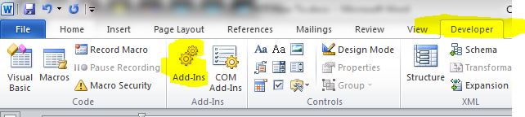
Once you’ve selected Add-Ins in the Ribbon above you will be presented with this dialog box | After pressing Add you are presented with a dialog box asking for the location of the file. Enter the location of the file. | And just like you saw in the 1st screen shot “CB Utilities v2.dotm (Or whatever file you chose) will be added to the list and checked
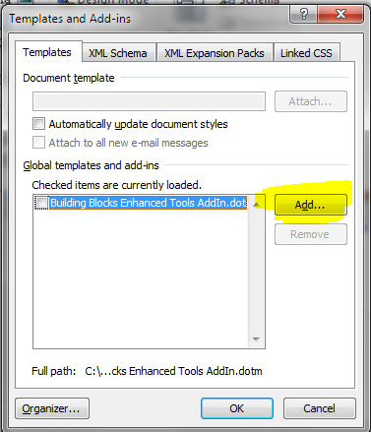 | 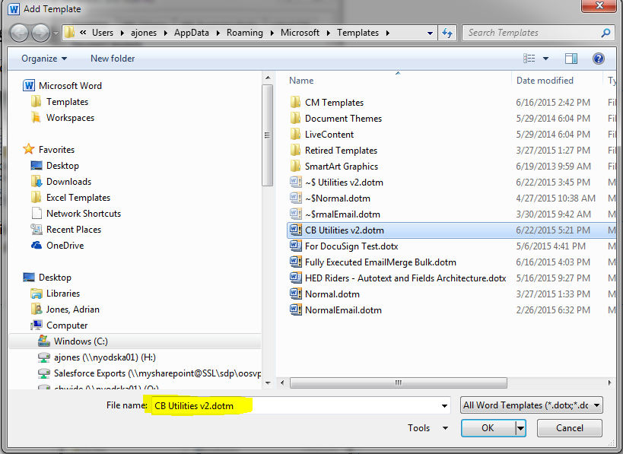 | 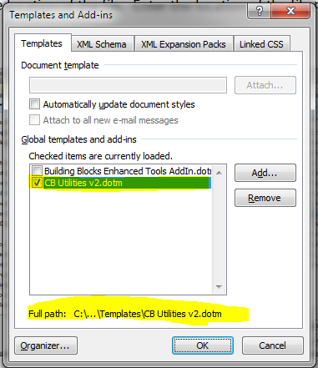
If you cannot see the Developer Tab, right-click on the menu/Ribbon and select Customize the Ribbon | Selecting Customize the Ribbon will bring you here (see below) and check Developer
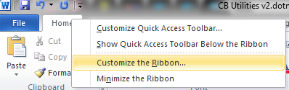 | 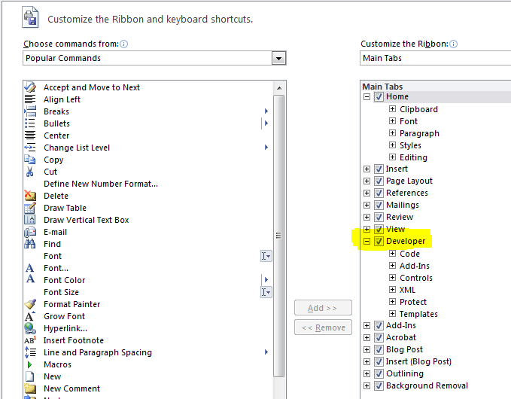

Notes on Code
Notes on “Rider Fields”
The riders in our agreement templates are If fields. They sit in a single paragraph, have text highlighted and begin with “-“, end with a “:” and the field starts after that.

